🌱 What is Bean Scope in Spring Boot?
In Spring, a Bean is an object that is created, managed, and destroyed by the Spring IoC container.
👉 Bean Scope defines how long a bean lives and how many instances of that bean Spring creates.
In simple words:
Bean scope decides “how many objects?” and “for how long?”

🧠 Why Do We Need Bean Scope?
Imagine this situation:
- Some objects should be shared by everyone (like configuration)
- Some objects should be new every time (like user input forms)
- Some objects should live only during a web request
- Some should live per logged-in user
👉 Bean scope helps control memory, performance, and correctness

🧩 Types of Bean Scope in Spring Boot
Spring provides 5 main bean scopes:
Scope Name | Keyword | Where Used
Singleton | singleton | Default, all apps
Prototype | prototype | All apps
Request | request | Web apps
Session | session | Web apps
Application | application | Web apps
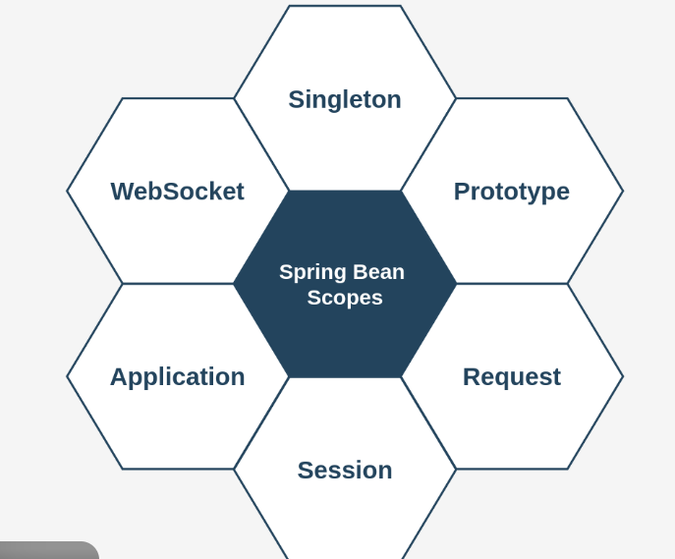
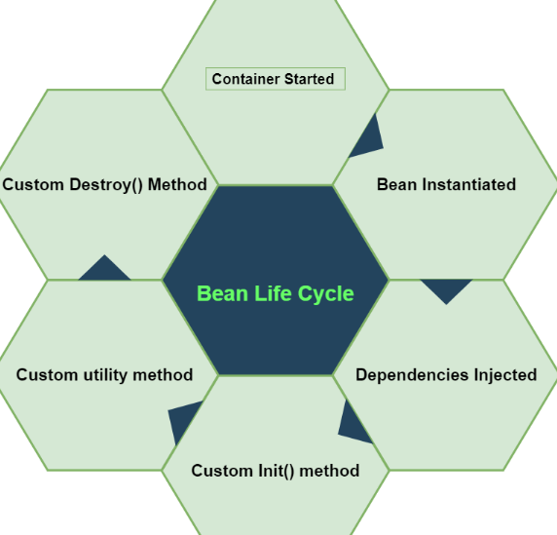
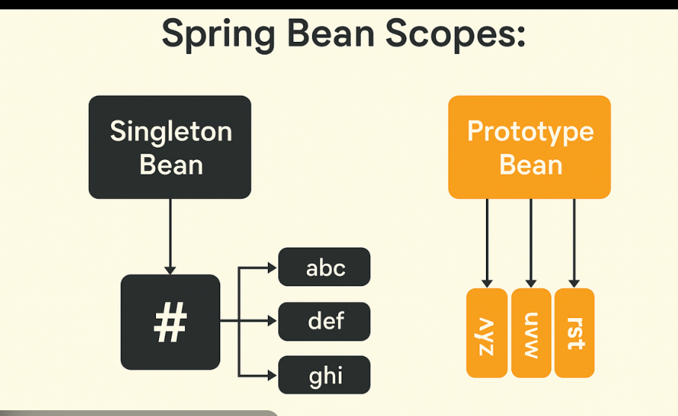
What is Singleton Scope in Spring?
- In Spring, by default, every bean is singleton.
- That means: only ONE object is created for the bean in the Spring container.
- Every time you request that bean, Spring returns the same object (same memory reference).

Step-by-step (STS) — Build a Simple Singleton Example
Step 1: Open STS and Create a Spring Boot Project
- Open STS
- Click: File → New → Spring Starter Project
- Fill:
  - Name: SingletonScopeDemo
  - Type: Maven
  - Java: 17 (recommended)
  - Packaging: Jar
- Click Next
- Select dependencies:
  - ✅ Spring Web (optional, but okay)
  - (You can also do without Web, but Web is fine)
- Click Finish

Step 2: Create a Service Class (Bean)
- Go to package: com.example.demo
- Right click → New → Class
- Class name: MessageService
✅ MessageService.java
package com.example.demo;

import org.springframework.stereotype.Service;

@Service // This becomes a Spring Bean (Singleton by default)
public class MessageService {

public MessageService() {
System.out.println("MessageService Constructor Called: Bean Created");
}

public String getMessage() {
return "Hello! I am Singleton Bean";
}
}
📌 Key point:
- @Service makes it a Spring Bean.
- By default scope = singleton.

Step 3: Use the Bean in Main Class and Compare References
Open your main class (example): SingletonScopeDemoApplication.java
✅ SingletonScopeDemoApplication.java
package com.example.demo;

import org.springframework.boot.SpringApplication;
import org.springframework.boot.autoconfigure.SpringBootApplication;
import org.springframework.context.ApplicationContext;

@SpringBootApplication
public class SingletonScopeDemoApplication {

public static void main(String[] args) {

ApplicationContext context =
SpringApplication.run(SingletonScopeDemoApplication.class, args);

// Getting the same bean twice
MessageService obj1 = context.getBean(MessageService.class);
MessageService obj2 = context.getBean(MessageService.class);

System.out.println(obj1.getMessage());

// Checking whether both are same object
System.out.println("obj1 hashCode: " + obj1.hashCode());
System.out.println("obj2 hashCode: " + obj2.hashCode());

if (obj1 == obj2) {
System.out.println("✅ SAME OBJECT => Singleton Scope Confirmed!");
} else {
System.out.println("❌ Different Objects => Not Singleton");
}
}
}

Step 4: Run the Application in STS
- Right click project → Run As → Spring Boot App
- Check the console output.

Step 5: Understand the Output
You will see something like:
- MessageService Constructor Called: Bean Created ✅ (only once)
- obj1 hashCode: 123456
- obj2 hashCode: 123456 ✅ same
- ✅ SAME OBJECT => Singleton Scope Confirmed!
📌 Meaning:
- Constructor runs once → only one bean created.
- Both requests return same instance.

(Optional) Step 6: Explicitly Mention Singleton Scope (Not Required, but for learning)
You can force it like this:
import org.springframework.context.annotation.Scope;
import org.springframework.stereotype.Service;

@Service
@Scope("singleton")
public class MessageService { }
📌 But remember: Spring already uses singleton by default, so this is optional.

What is Bean Scope (1-line recap)
Bean scope defines how many objects Spring creates for a bean and how long they live inside the Spring container.

🔹 Singleton vs Prototype – Core Difference
Aspect | Singleton Scope | Prototype Scope
Number of Objects | Only ONE instance per Spring container | New instance every time it is requested
Default Scope | ✅ Yes (default) | ❌ No
Object Creation Time | Created at application startup | Created on demand
Shared or Not | Shared across the entire app | Not shared
Memory Usage | Low (one object reused) | Higher (multiple objects created)
Spring Lifecycle Control | Spring manages full lifecycle | Spring manages creation only
Best For | Stateless services | Stateful / temporary objects
Thread Safety | Must be thread-safe | Thread-safe by design (new object per use)

What is Prototype Scope in Spring?
- In prototype scope, Spring creates a NEW object every time you request the bean.
- So if you call getBean() two times → you get 2 different objects.

Step-by-step (STS) — Build a Simple Prototype Example
Step 1: Create a Spring Boot Project in STS
- Open STS
- Go to: File → New → Spring Starter Project
- Enter:
  - Name: PrototypeScopeDemo
  - Type: Maven
  - Java: 17 (recommended)
  - Packaging: Jar
- Click Next
- Select dependency:
  - ✅ Spring Web (optional, but fine)
- Click Finish

Step 2: Create a Bean Class with Prototype Scope
- Go to package: com.example.demo
- Right click → New → Class
- Class name: EmployeeService
✅ EmployeeService.java
package com.example.demo;

import org.springframework.context.annotation.Scope;
import org.springframework.stereotype.Service;

@Service
@Scope("prototype") // ✅ Prototype: new object every time
public class EmployeeService {

public EmployeeService() {
System.out.println("EmployeeService Constructor Called: NEW Bean Created");
}

public String getEmployeeInfo() {
return "Employee Service - Prototype Bean";
}
}
📌 Key point:
- @Scope("prototype") makes this bean prototype instead of singleton.

Step 3: Modify Main Class to Request Bean Twice
Open your main class (example: PrototypeScopeDemoApplication.java) and write this:
✅ PrototypeScopeDemoApplication.java
package com.example.demo;

import org.springframework.boot.SpringApplication;
import org.springframework.boot.autoconfigure.SpringBootApplication;
import org.springframework.context.ApplicationContext;

@SpringBootApplication
public class PrototypeScopeDemoApplication {

public static void main(String[] args) {

ApplicationContext context =
SpringApplication.run(PrototypeScopeDemoApplication.class, args);

// Getting bean 2 times
EmployeeService obj1 = context.getBean(EmployeeService.class);
EmployeeService obj2 = context.getBean(EmployeeService.class);

System.out.println(obj1.getEmployeeInfo());

// Print hashCode to verify different objects
System.out.println("obj1 hashCode: " + obj1.hashCode());
System.out.println("obj2 hashCode: " + obj2.hashCode());

if (obj1 == obj2) {
System.out.println("❌ SAME OBJECT => Not Prototype");
} else {
System.out.println("✅ DIFFERENT OBJECTS => Prototype Scope Confirmed!");
}
}
}

Step 4: Run the Project in STS
- Right click your project
- Run As → Spring Boot App
- Watch the console output

Step 5: Understand the Output (Very Important)
You will see something like:
- EmployeeService Constructor Called: NEW Bean Created
- EmployeeService Constructor Called: NEW Bean Created ✅ (called twice!)
- obj1 hashCode: 111111
- obj2 hashCode: 222222 ✅ different
- ✅ DIFFERENT OBJECTS => Prototype Scope Confirmed!
📌 Meaning:
- Constructor runs every time you call getBean()
- That proves Spring is creating new objects.

Quick Comparison (Freshers Friendly)
Scope | Objects Created | When Created?
Singleton (default) | Only 1 | Created once at startup
Prototype | Many | New object each time getBean() is called

🔹 What is Request Bean Scope?
Request scope means:
🟢 One bean instance is created for ONE HTTP request
🟢 The bean lives only during that request
🟢 After the response is sent → the bean is destroyed
👉 This scope works only in web applications (Spring MVC / REST).

What is Request Scope?
- Request scope means: Spring creates one new bean object per HTTP request.
- If you hit an API endpoint 2 times, Spring gives 2 different objects (one for each request).
- ✅ Works only in Web Applications (because it needs HTTP request)

Step-by-step (STS) — Request Scope Example
Step 1: Create a Spring Boot Project in STS
- Open STS
- Go to: File → New → Spring Starter Project
- Enter:
  - Name: RequestScopeDemo
  - Type: Maven
  - Java: 17 (recommended)
  - Packaging: Jar
- Click Next
- Select dependency:
  - ✅ Spring Web
- Click Finish

Step 2: Create a Request Scoped Bean Class
- Go to package: com.example.demo
- Right click → New → Class
- Name: RequestBean
✅ RequestBean.java
package com.example.demo;

import java.util.UUID;

import org.springframework.stereotype.Component;
import org.springframework.web.context.annotation.RequestScope;

@Component
@RequestScope // ✅ New object for every HTTP request
public class RequestBean {

private String requestId;

public RequestBean() {
this.requestId = UUID.randomUUID().toString();
System.out.println("RequestBean Created: " + requestId);
}

public String getRequestId() {
return requestId;
}
}
📌 What this does:
- @Component → Spring will manage this class as a bean
- @RequestScope → Spring creates a new object for each request
- UUID helps you see the difference clearly

Step 3: Create a Controller to Test Request Scope
- Right click package → New → Class
- Name: TestController
✅ TestController.java
package com.example.demo;

import org.springframework.web.bind.annotation.GetMapping;
import org.springframework.web.bind.annotation.RestController;

@RestController
public class TestController {

private final RequestBean requestBean;

// Constructor Injection
public TestController(RequestBean requestBean) {
this.requestBean = requestBean;
}

@GetMapping("/test")
public String testRequestScope() {

return "Request ID: " + requestBean.getRequestId()
+ " | Bean hashCode: " + requestBean.hashCode();
}
}
📌 Key learning:
- We inject RequestBean into controller
- Each time you call /test, you should see a new requestId and new hashCode

Step 4: Run the Spring Boot Application
- Right click project → Run As → Spring Boot App
- Wait until console shows something like:
  - Tomcat started on port 8080

Step 5: Test in Browser / Postman
Option A: Browser
Open:
- http://localhost:8080/test
Refresh the page multiple times.
Option B: Postman
Send GET request:
- GET http://localhost:8080/test
Send it again.

Step 6: Understand the Output
Each request will give output like:
- First time:
  - Request ID: abc... | Bean hashCode: 12345
- Second time:
  - Request ID: xyz... | Bean hashCode: 67890
✅ You will notice:
- Request ID changes
- hashCode changes
➡️ That confirms Request Scope

Freshers Quick Comparison
Scope | Object Creation
Singleton (default) | One object for entire app
Prototype | New object every time getBean()
Request Scope | New object for every HTTP request

What is Session Scope in Spring Boot?
Session scope means:
🟢 One bean instance per HTTP session (per user)
🟢 The same bean is reused across multiple requests of the same user
🟢 Bean is destroyed when the session expires or user logs out
📌 Works only in web applications (Spring MVC / REST).

🔹 Simple Definition (Interview-Ready)
Session scope creates one bean per user session and keeps it alive until the session ends.

🔹 Why Do We Need Session Scope?
In web apps:
- A user makes multiple requests
- Some data must persist across requests
- But should not be shared with other users
Step 1: Create a Spring Boot Project in STS
- Open STS
- Go to: File → New → Spring Starter Project
- Enter:
  - Name: SessionScopeDemo
  - Type: Maven
  - Java: 17 (recommended)
  - Packaging: Jar
- Click Next
- Select dependency:
  - ✅ Spring Web
- Click Finish

Step 2: Create a Session Scoped Bean
- Go to package: com.example.demo
- Right click → New → Class
- Name: SessionBean
✅ SessionBean.java
package com.example.demo;

import java.util.UUID;

import org.springframework.stereotype.Component;
import org.springframework.web.context.annotation.SessionScope;

@Component
@SessionScope // ✅ One object per HTTP session
public class SessionBean {

private final String sessionId;

public SessionBean() {
this.sessionId = UUID.randomUUID().toString();
System.out.println("SessionBean Created: " + sessionId);
}

public String getSessionId() {
return sessionId;
}
}
📌 What you learn here:
- @Component → Spring creates/manages this bean
- @SessionScope → One bean per session
- UUID helps you clearly see session changes

Step 3: Create a Controller to Test Session Scope
- Right click package → New → Class
- Name: TestController
✅ TestController.java
package com.example.demo;

import org.springframework.web.bind.annotation.GetMapping;
import org.springframework.web.bind.annotation.RestController;

@RestController
public class TestController {

private final SessionBean sessionBean;

// Constructor Injection
public TestController(SessionBean sessionBean) {
this.sessionBean = sessionBean;
}

@GetMapping("/session-test")
public String sessionTest() {
return "Session ID: " + sessionBean.getSessionId()
+ " | Bean hashCode: " + sessionBean.hashCode();
}
}
📌 What this endpoint does:
- Returns the sessionId and hashCode
- In the same browser session, these stay the same.

Step 4: Run the Application in STS
- Right click project → Run As → Spring Boot App
- Confirm in console:
  - Tomcat started on port 8080

Step 5: Test the Session Scope (Very Important)
Test A: Same Browser (Same Session)
- Open in browser:
  - http://localhost:8080/session-test
- Refresh multiple times.
✅ You should see:
- Same Session ID
- Same hashCode

Test B: Incognito / Another Browser (New Session)
- Open Incognito window (or open another browser like Edge)
- Open:
  - http://localhost:8080/session-test
✅ You should see:
- Different Session ID
- Different hashCode
That proves: new session → new bean object

Expected Output Behavior (Freshers Friendly)
Same Browser Refresh:
- Session ID: AAA | hashCode: 1111
- Session ID: AAA | hashCode: 1111
- Session ID: AAA | hashCode: 1111
Incognito / New Browser:
- Session ID: BBB | hashCode: 2222

Quick Comparison Table
Scope | Bean Lifetime
Singleton (default) | One object for whole app
Prototype | New object every time you request it
Request Scope | New object for every HTTP request
Session Scope | One object per user session
What is Application Scope?
- Application scope means: Spring creates ONE bean object for the entire web application.
- The same bean is shared across:
  - all users
  - all sessions
  - all requests
✅ In simple words: It behaves like a global shared object in the application.
Note: In Spring web, Application Scope is same as ServletContext scope.

Step-by-step (STS) — Application Scope Example
Step 1: Create Spring Boot Project in STS
- Open STS
- Go to: File → New → Spring Starter Project
- Enter:
  - Name: ApplicationScopeDemo
  - Type: Maven
  - Java: 17 (recommended)
  - Packaging: Jar
- Click Next
- Select dependency:
  - ✅ Spring Web
- Click Finish

Step 2: Create an Application Scoped Bean
- Go to package: com.example.demo
- Right click → New → Class
- Name: AppBean
✅ AppBean.java
package com.example.demo;

import java.util.UUID;

import org.springframework.stereotype.Component;
import org.springframework.web.context.annotation.ApplicationScope;

@Component
@ApplicationScope // ✅ One object for the whole application
public class AppBean {

private final String appId;

public AppBean() {
this.appId = UUID.randomUUID().toString();
System.out.println("AppBean Created (Only once for whole app): " + appId);
}

public String getAppId() {
return appId;
}
}
📌 What you learn:
- @Component → Spring will manage the bean
- @ApplicationScope → only ONE instance for the entire application
- UUID helps you identify the same object clearly

Step 3: Create Controller to Test Application Scope
- Right click package → New → Class
- Name: TestController
✅ TestController.java
package com.example.demo;

import org.springframework.web.bind.annotation.GetMapping;
import org.springframework.web.bind.annotation.RestController;

@RestController
public class TestController {

private final AppBean appBean;

public TestController(AppBean appBean) {
this.appBean = appBean;
}

@GetMapping("/app-test")
public String appScopeTest() {
return "Application ID: " + appBean.getAppId()
+ " | Bean hashCode: " + appBean.hashCode();
}
}
📌 Meaning:
- Every request (from any user/browser) will use the same AppBean object

Step 4: Run the Application in STS
- Right click project → Run As → Spring Boot App
- Console will show something like:
  - Tomcat started on port 8080
Also you should see:
- AppBean Created (Only once for whole app): ...
✅ That line appears only once when app starts.

Step 5: Test in Browser
Open:
- http://localhost:8080/app-test
Test A: Refresh many times
✅ You will see same:
- Application ID
- hashCode
Test B: Open in another browser (Edge/Incognito)
✅ You will still see same:
- Application ID
- hashCode
That confirms Application scope.

Expected Output Behavior
In Chrome:
- Application ID: AAA | hashCode: 1111
In Edge / Incognito:
- Application ID: AAA | hashCode: 1111 ✅ same
📌 Meaning:
- Even different users/browsers get the same bean instance.

Freshers Quick Comparison
Scope | New Bean Created When?
Singleton | Once for entire Spring container
Prototype | Every time you request the bean
Request | Every HTTP request
Session | Every user session
Application | Once for entire web application

